About Living

Death teaches us not to rush past the things we'll wish we had more of at the very end of life
by Alexandra RosasSunday, August 25, 2013
- Share This:
- 7
- 11
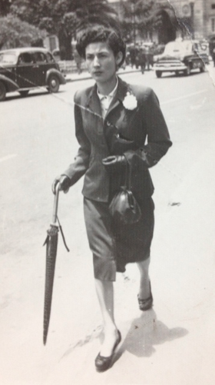
Twenty-five years ago, I held my grandmother's hand as she passed away. Two and half weeks ago, it was my mother's hand that I held as she left our world.
I was there for the last days of life with both my mother and grandmother, and in our time together, they spoke of things with a sadness and urgency that they never had before.
There’s an old photo I have of my mother, which I’ve always loved. In it, she’s a young, sharply dressed working woman in South America, and you can feel the determination in her stride. I showed her this photo just a few weeks ago, and you could've heard the pride in my voice as I asked if she remembered where she was going on the day it was taken.
"I have always hated that picture," she said, which startled me. "I was always in a hurry. Hurrying. Always. For what?" She took a deep breath, and gently said it one more time, "Always in a hurry ...."
What left me astonished and teary-eyed was not the surprise of her hating the picture, but that these words were exactly the ones my grandmother had spoken to me on the morning of her own passing. I had been sitting vigil at her bedside and she was growing weaker with each day in the hospital. Stroking her hand, I spoke softly to her, "Abuela. Abuela, do you hear me? Remember when you would take us to the grocery store across the street from our house at the start of every summer, and you began our first day of vacation with a popsicle?"
- 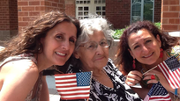

What's Your Favorite Moment in Your Life?
Warning: This could be a trick question
Smiling, with her eyes still closed, she quietly answered, "I would tell you all to hurry, make your flavor choices, and to hurry. There was much to do. I would let you take your time choosing now, if I could. Things could have waited."
What the dying want us to do — and wish for us to know — is to regard our lives as precious moments making up our days. They want us to focus less on the big picture of building a large body of evidence that proves our accomplishments, and more on the true wonders in our life — the kind where we find unexpected beauty that will be remembered with a wistful smile.
Like walking with your child alongside you, going somewhere without purpose. Or waiting patiently while five- and six-year-old children choose, change their minds, choose, and then change their minds again, about the root-beer-flavored or the banana-flavored popsicles.
My mother and grandmother were telling me loud and clear that as we live our lives, we have to stop running and chasing what we think leads to happiness, and slow down before we rush past the very thing we'll wish we had more of at the very last hours of our days.
It's not too late to make sweet memories of children or grandchildren skipping alongside us, of us just being and not doing, of grateful children looking up to us smiling with orange-stained mouths, yelling excitedly, "Thank you for waiting for me until I picked my flavor, Grandma! I didn't know if I wanted the green or the orange!"
After hearing these words — not once, but twice — from loved ones who know everything they are about to leave behind, I know this is something I'll be working on to change.
And I'm forever grateful for the second chance.

