Name:_______________________ Mr. Chiaramonte

Peer Education Social Studies Department

Culture Cutters
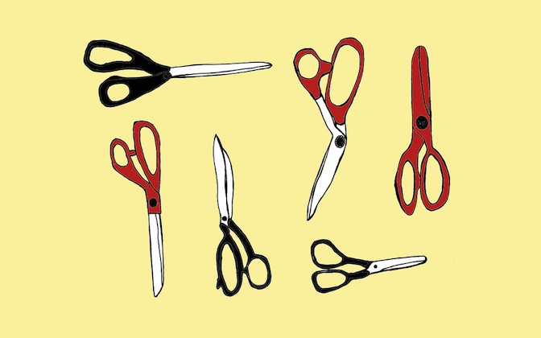

In 100 words or less, tell us what you'd permanently cut away from our culture, and why.

