Name:_______________________ Mr. Chiaramonte

Peer Education Social Studies Department

Heart Your Art
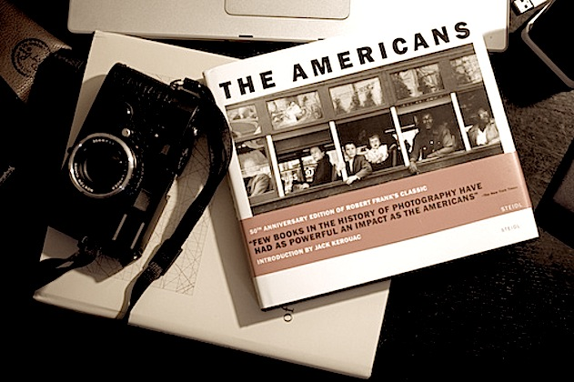

List the major works of art—music, literature, fine arts—that have most inspired you in your life and why?

