Name. _____________________________________ Mr. Chiaramonte
Peer Education Social Studies Department

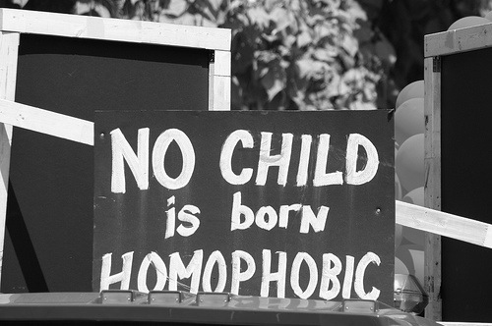

Heterocenterism – Heterocentrism is the ideology and assumption that all people are heterosexual.
Heterosexism – Heterosexism is the system of oppression that gives privileges to heterosexual people to the disadvantage of those who are not.
Homophobia – Homophobia is the fear, discomfort, or hatred of non-heterosexual people that is manifested on the individual level.
The ideology of heterocentrism creates the system of oppression (heterosexism), and both create the individual manifestation of homophobia.
