Name. _____________________________________ Mr. Chiaramonte
Peer Education Social Studies Department

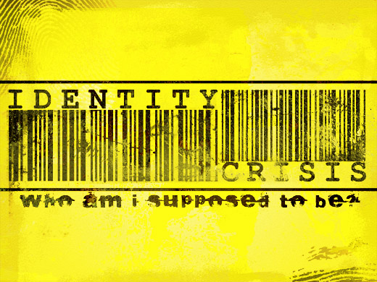
*In a paragraph answer the following three questions to be shared out loud:

- What is identity?

- How is identity developed?
- How does identity affect our relationships?

Identity-
*The collective aspect of the set of characteristics by which a thing or person is definitively recognized or known.
*The set of behavioral or personal characteristics by which an individual is recognizable as a member of a group.

Think about how a person’s different identity categories might create sameness as well as uniqueness.
- Our identity consists of the various characteristics we use to categorize and define ourselves and the various characteristics that are constructed by those around us. Sometimes people only think of identity as those visible characteristics of a person, but sometimes our identity characteristics are invisible.

- Read the following identity characteristics list:
  - Gender
  - Ethnicity
  - Race
  - Religion
  - Socioeconomic status
  - Language
  - Marital/relationship status
  - Family size and composition
  - Sexual orientation
  - Education
  - Career
Think about which of these characteristics are visible, and which are invisible?

Apply
Think about the list of characteristics again. For each image, use the categories to describe the subject.
Look at the picture. Complete the table below.
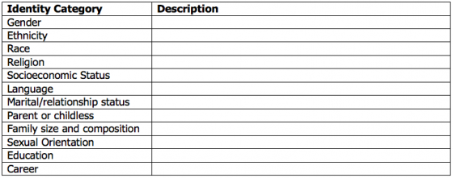

Share your thoughts with a partner.

Go Deeper
Match the picture to its story.
Name: Elizabeth
I am a high school student. Everyone thinks that I am a Hispanic female. I am skinny and have long brown hair, and I wear glasses.
Name: Brandon
Everyone thinks that I am in high school. I am athletically built. I always get complimented on my smile, and people tell me that I must be happy all the time because of it.
Name: Guadalupe
I am Guadalupe. Everyone thinks that I am in grade school and a child. I am short and Latina. I have dark brown eyes and long brown hair. People always compliment me on my manners and say that I am very nice and polite.

Reflect
Take a few moments for reflection using these questions:
- Did you match Elizabeth, Brandon and Guadalupe to their respective pictures?

- What were the identity characteristics you established for each of their stories?

- Why do you think you were successful or not successful in defining those categories for someone else?

- What assumptions did you make in order to do that? What do those assumptions tell you about yourself?

- What did you learn from their individual stories?

Share your answers with the group.

Name. _____________________________________ Mr. Chiaramonte
Peer Education Social Studies Department
The following activity will take you through a series of statements about your identity.
Step 1—Create a two-column chart like the one below on a sheet of paper.
Step 2—For each statement, offer one to three different endings. For example, if the statement begins with “I am,” you can complete the sentence by saying a teacher, happy, a runner. 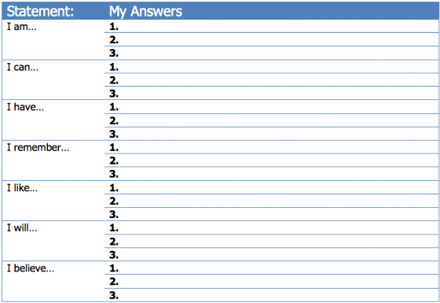

Go Deeper
You now have a list of approximately 21 statements that contribute to your personal identity. These are all important pieces that contribute to who you are.
Next, add a third column to your chart. Identify if each statement is visible/invisible/both.
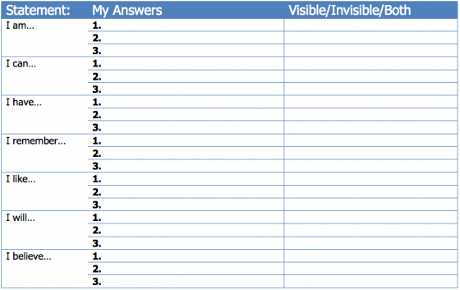
How many of the characteristics you included in your list fit neatly into one of the following categories: Gender, Ethnicity, Race, Religion, Socioeconomic Status, Language, Sexual Orientation, Education, Career, Relationship Status?
Reflect
Take a moment to look back at the statements about yourself.
- Were you surprised by any of your answers?
- How do these statements help you to better understand who you are as a person?
- What are the visible characteristics of your identity?
- What are the invisible characteristics?
In Summary
Although we construct our identities to some extent, society does, too.
Our identities affect the way we interact with the world.
Our identities affect the way the world interacts with us.

